**Spicy Fried Chicken Sandwich Recipe**

1. **Dish**: Spicy Chicken Sandwich
2. **Origin**: American
3. **Source:** Original recipe!
4. **Category:** Main Dish
5. 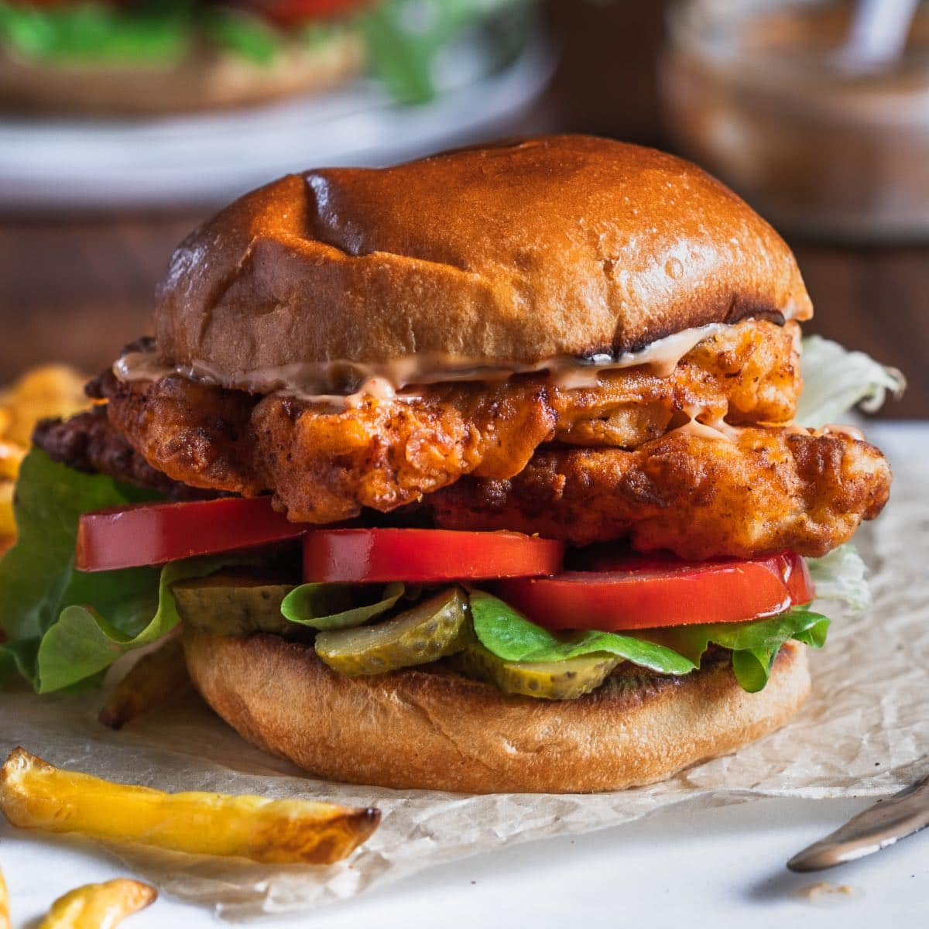
6. Spicy-chicken-sandwich-recipe.jpg
7. **Recipe** **Ingredients**:
   1. **Chicken Prep:**
      1. 1.5lb chicken thigh
      2. 2 tbsp garlic powder
      3. 2 tbsp smoked paprika
      4. 1 tbsp cumin
      5. 1 tbsp black pepper
      6. dash/pinch of salt
      7. 3 cups of flour
      8. 3 tbsp oil
      9. 1 tbsp hot sauce
   2. **Marinade**
      1. 1 cup preferred hot sauce
      2. 2 eggs
      3. 1 tsp black pepper
      4. dash salt
      5. 4 tbsp melted butter
   3. **Bun/toppings**
      1. 4 hamburger buns
      2. crinkled pickles
      3. tomatoes
      4. lettuce
      5. Chipotle Mayo

8. **Recipe Steps**:

* Wash your chicken and leave it to rest in a bowl
* Begin working on your marinade. In a medium/large bowl, combine your hot sauce, eggs, black pepper, butter, and salt one-by-one. Mix until fully dissolved
* In a separate bowl, combine flour, garlic powder, paprika, cumin, black pepper, salt together. Whisk thoroughly.
* Prep your chicken thigh by poking holes with a fork across its surface on both sides. Place your chicken into the marinade mix and let rest for 1-2h. (if speed is needed, can do a quick soak of 10-15min)
* Place your marinated chicken into flour mixture and toss. Place back in marinade and redcoat. Repeat 2-3 times.
* Prepare your vegetables and set them aside.
* Grab a deep pan and add your oil on medium-high heat. Fry in oil for 4-5min on each side.
* Remove chicken thigh and toss in 1tbsp hot sauce before plating.
* Combine the buns, toppings, and chicken and serve!

9. chicken_breast_marinade.jpeg

10. Chicken breast will be marinated for one to two hours.

11. bun_with_toppings.jpeg

12. Example of the prepared hamburger buns before chicken is added

13. final_product_chicksandwich.jpeg

14. Your succulent final product!

**15. Johann Tsegay**